Working with AgroCares: Precision farming and food production

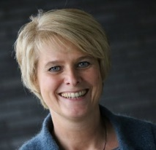
Angelique van Helvoort is teamleader Marketing and Communication for AgroCares. As an organisation AgroCares is primarily concerned with providing information that can support food production. This information is based on research carried out by its predecessors AgroExpertus and EuroFinsAgro as well as its own experience.
There is an urgent need to increase access to food given the rapid increase in world population. Climate change is also having a serious and negative impact on food production and farmers face changing soil and water conditions on their land. The materials developed by AgroCares, Angelique explains, enable farmers, farm communities and extensionists to measure key soil and plant health parameters and if problems are identified they can take immediate and appropriate action.
Angelique completed her study in communication in Utrecht in 1990 where special emphasis was given to the economic, political and social aspects of communication processes. Subsequently she worked in the information sectors of several organisations where she often had to deal with the complicated process of making the implications of often sensitive issues accessible to those looking for information. While working as senior press officer at the Ministry of LNV (Agriculture, Nature and Food Quality), for example, she was responsible for keeping the press and media informed when swine fever and BSE (mad cow disease) broke out. Technical and potentially socially disturbing events. Equally challenging was providing journalists with information when foot and mouth disease was rampant in the Netherlands.
Angelique’s work as senior press officer for Staatsbosbeheer provides an example of how difficult it could sometimes be to satisfy those wanting to know what an organisation was doing. Maintaining forested areas and preserving biodiversity is Staatsbosbeheer’s main concern but sometimes it involves cutting back woodland areas. This “deforestation” can lead to emotional criticism and then providing rational explanations to press and local people can be very difficult Angelique says with a sigh.
For some time she worked in Singapore teaching English at a local high school. When she returned to the Netherlands she decided to settle in Wageningen attracted by its international environment and the beauty and diversity of the natural surroundings. It was in Wageningen that she came into contact with the SoilCares Foundation, which had a base in Kenya and was closely associated with the Dutch Sprouts soil specialist organisation.
For four years Angelique worked for Dutch Sprouts following the way it set about developing tools and processes to strengthen the capacity of farmers – especially those in the South - and help them identify the composition of their soil. Currently she is responsible for marketing and communication at AgroCares, a Dutch AgroTech company based in Wageningen and closely associated with SoilCares. Providing information on the data-based precision farming tools that these organisations have developed to give farmers on the spot, fast, reliable and customised data on the nutrients composition of their soil is an important part of her work. She is also well aware of the way these tools help farmers avoid the cost and time involved in sending soil samples for conventional laboratory analysis.
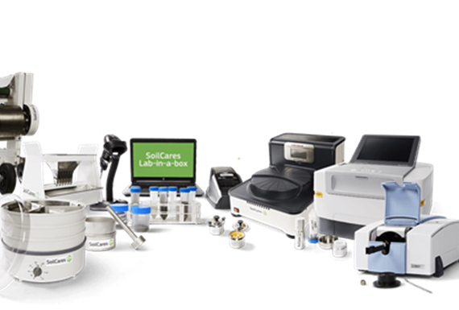
The innovative sensor technology involved in the tools developed by AgroCares combined with data collection and the conversion of analytical data and sensor data into field and client specific recommendations, Angelique explains, enables farmers and extensionists to scan and immediately identify the amounts of nitrogen, phosphorus and potassium in the soil – nutrients that are required by crops in large amounts. AgroCares subsidiary SoilCares developed the Lab-in-a-Box, a compact modern laboratory to enable soil analysis on site.
Lab-in-a-Box

The Scanner may look very simple from the outside but the technology inside is very sophisticated and ground-breaking. In particular how the scans from the Scanner are compared with the data in the cloud and how recommendations are given via the smartphone.
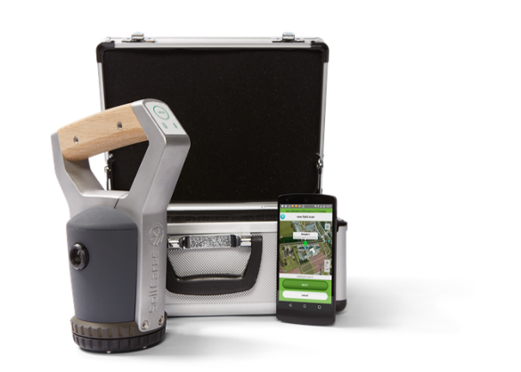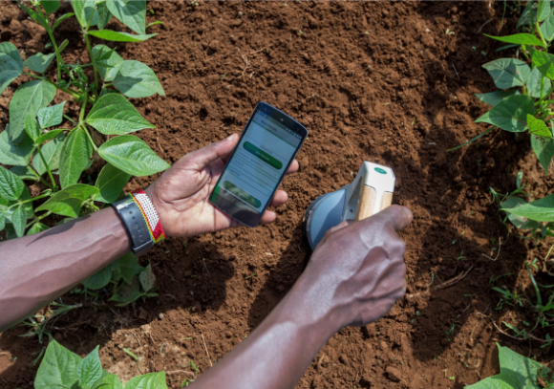
The Scanner: instant, on-the-spot monitoring of nutrients in soil, feed and leaf
The Scanner can also be used to identify the nutrient composition in animal feed and plants as well as locating the presence of potentially harmful insects. Using AgroCares precision farming technology to monitor soil fertility enables farmers to monitor their crops during growth and helps them contribute to meeting the growing demand for food and biomass without putting soil fertility levels under pressure. In this way soil degradation and productivity loss can be minimised because the Scanner can identify poor soil nutrient management practices.
In this way the AgroCares nutrient Scanner provides farming communities with a simple and direct way to analyse crops, raw materials and soil. It is a tool that is easily hand-held and it can provide nutrient information within ten minutes. Once the leaves, feed or soil have been scanned the data are uploaded via an app which is linked to a database that can provide farmers and those working with them with a report on how to counter their agrarian problems. Cattle farmers can also use the Scanner to assess the nutrient quality of animal feed. In this way “precision feeding” makes it possible for them to analyse food raw materials and silages for a large range of nutrients.
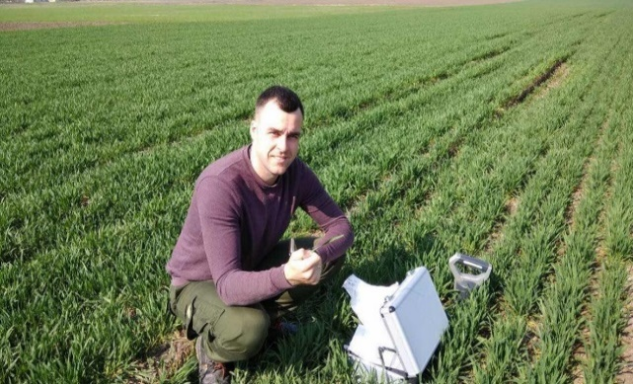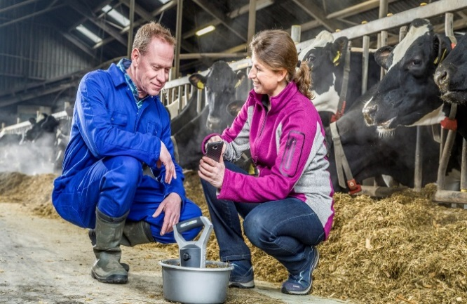
Digital insect scouting using the Scanner Measuring the quality of nutrients in silages and raw materials

A third tool is the Scoutbox. It scans insect traps in fields and greenhouses and software tells where harmful insects are located, for deciding what is needed to protect the crops. (For more information on the tools see https://www.agrocares.com)

These tools are now being used in an increasing number of countries. Angelique explains that AgroCares is also forming strategic alliances with partners from all over the world including the Dutch Rabobank Foundation, Trouw Nutrition (a Nutreco company) and the World Bank. She expects that the number of organisations and institutions prepared to support AgroCares will increase steadily in the coming years given the need for investment in alternative farming techniques to counter the severe and growing impact of food shortages worldwide.

